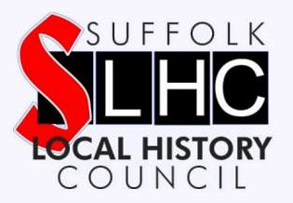
Would you like to be the
Recorder for:
FARNHAM &
STRATFORD ST. ANDREW

The Suffolk Local History Council runs a Recorders Scheme throughout Suffolk. We administer a network of volunteers to ensure that the ‘present’ is adequately recorded at local level for the ‘future’.

A Recorder will note significant happenings in their parish and collect their local parish magazines, leaflets, election pamphlets and newspaper cuttings. At the end of each year, they are asked to submit a short report summarising the activities of their parish. The reports are deposited at the Suffolk Record Office and available to future researchers together with the collected items.

If you are interested, please look at the Recorders Pack by visiting www.slhc.org.uk to acquaint yourself with the guidelines of the scheme. You do not need to be a historian; you do not need any qualifications other than an interest in your parish. In return you will receive a copy of the SLHC Newsletter and be invited to the annual conference specifically for Local Recorders. To volunteer to help in this important work, please contact recorders@slhc.org.uk

Would you like to be the
Local Recorder for:
FARNHAM &
STRATFORD ST. ANDREW

The Suffolk Local History Council runs a Recorders Scheme throughout Suffolk. We administer a network of volunteers to ensure that the ‘present’ is adequately recorded at local level for the ‘future’.

A Recorder will note significant happenings in their parish and collect their local parish magazines, leaflets, election pamphlets and newspaper cuttings. At the end of each year, they are asked to submit a short report summarising the activities of their parish. The reports are deposited at the Suffolk Record Office and available to future researchers together with the collected items.

If you are interested, please look at the Recorders Pack by visiting www.slhc.org.uk to acquaint yourself with the guidelines of the scheme. You do not need to be a historian; you do not need any qualifications other than an interest in your parish. In return you will receive a copy of the SLHC Newsletter and be invited to the annual conference specifically for Local Recorders. To volunteer to help in this important work, please contact recorders@slhc.org.uk

